
Touchstones
Netcards

Journey Netcards with Text

Baby HRJ
Blade of Grass HRJ
Book HRJ
Buddha HRJ

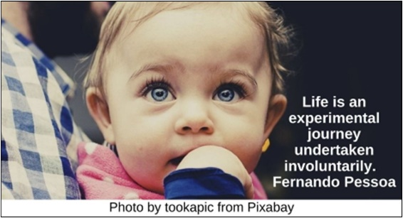

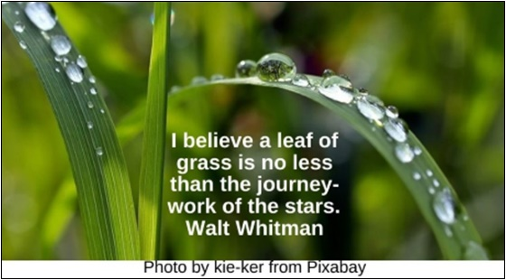

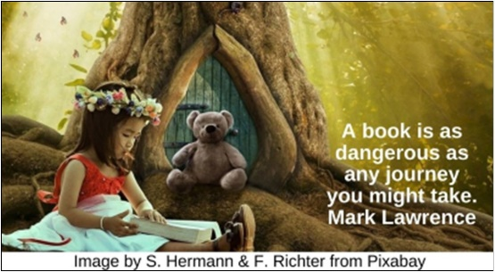

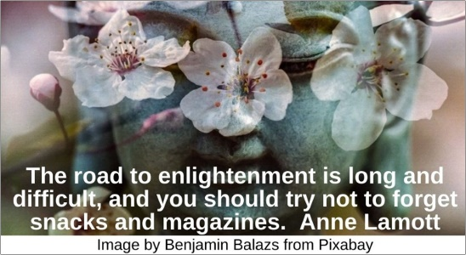

Change HRJ
Child HRJ
Closed Eyes HRJ
Dance HRJ

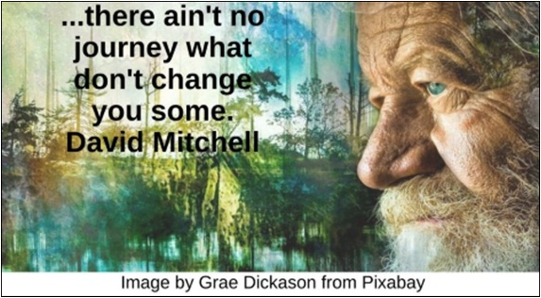

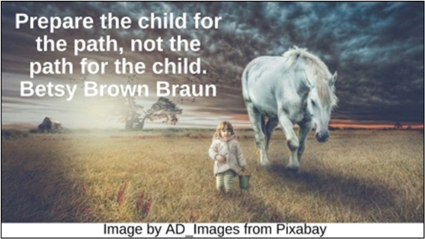



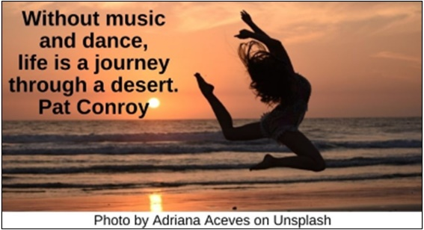

Diversity HRJ
Footsteps HRJ
Imagination HRJ
Lessons HRJ

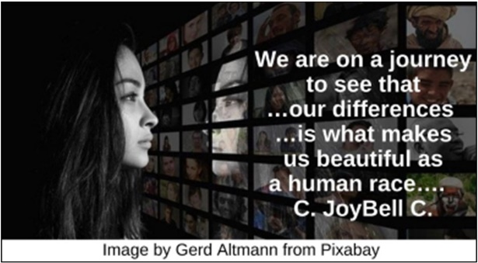

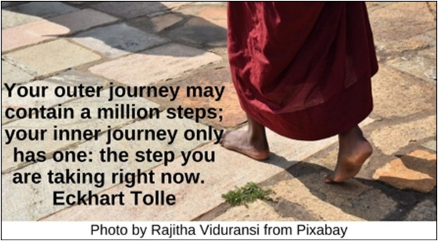

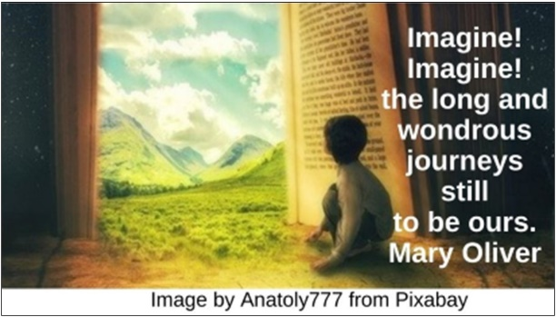

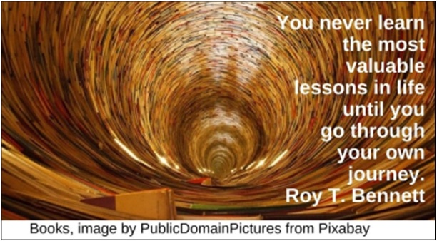

Let Go HRJ
Love Yourself HRJ
Next Step HRJ
No Fear HRJ

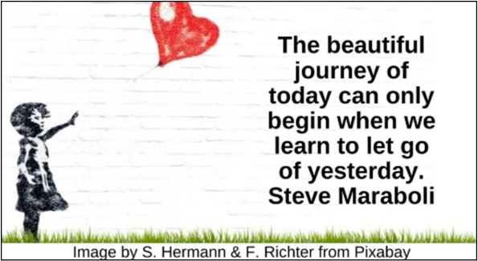

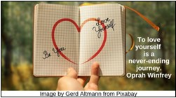

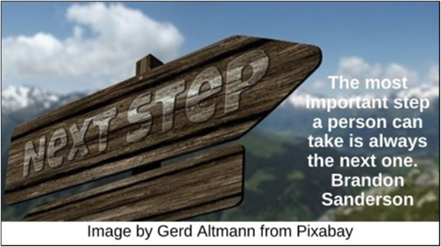

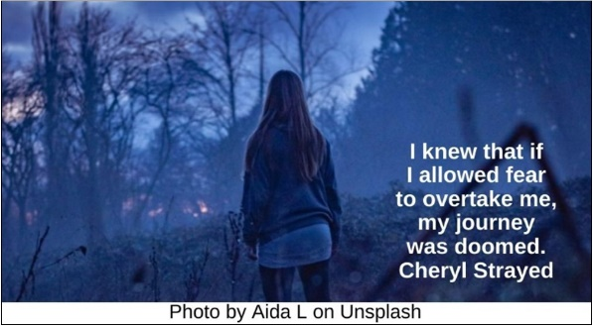

Nowhere HRJ
Resistance HRJ
Rocky HRJ
Secret HRJ

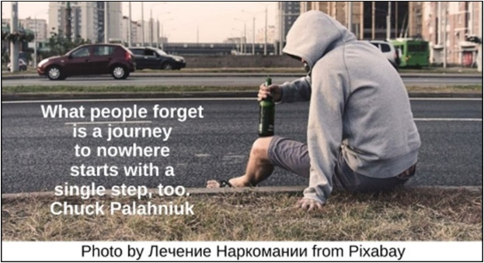

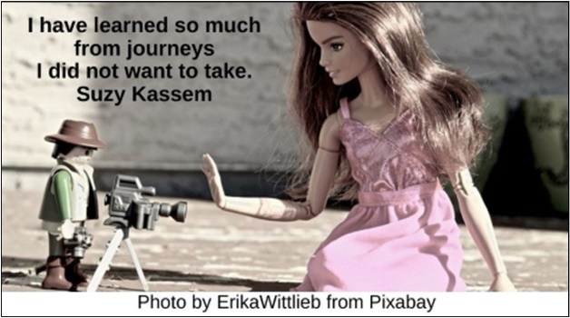

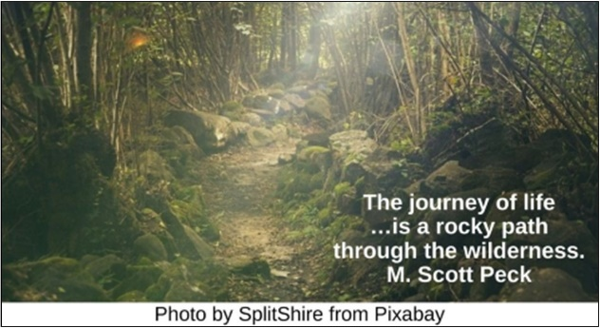

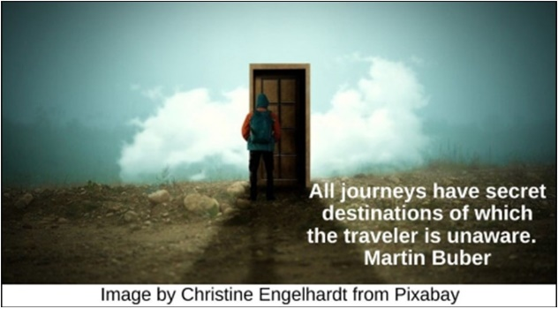

Shapes Us HRJ
Single Step HRJ
Teddy Bear HRJ
The End HRJ

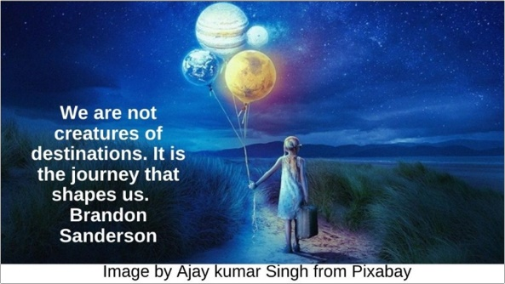

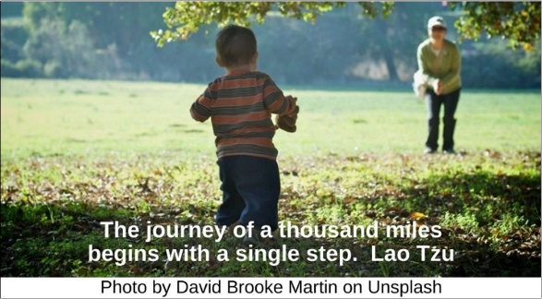

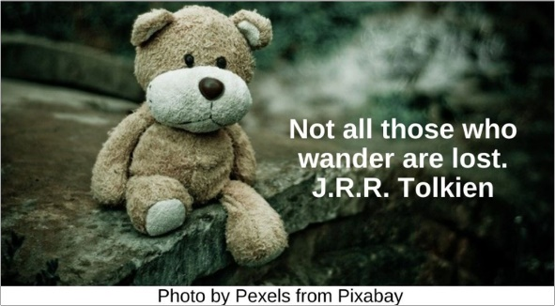

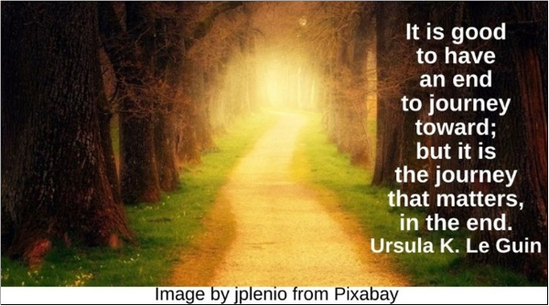

Time to Choose HRJ
Toward Home HRJ
Treat Those HRJ
Truth HRJ

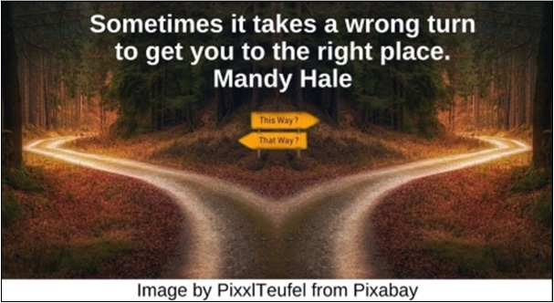

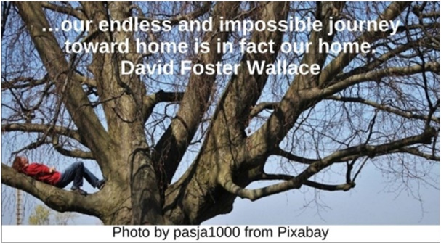

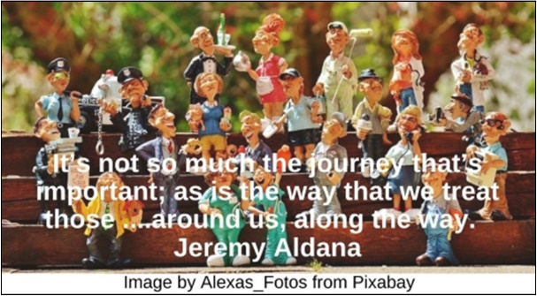

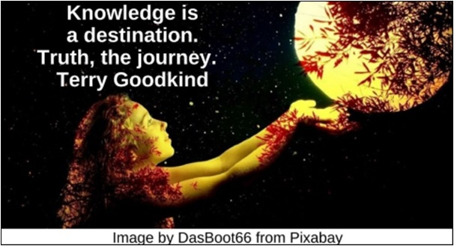

Unique HRJ
Which Way HRJ
Window HRJ

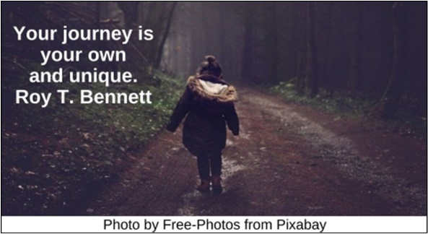

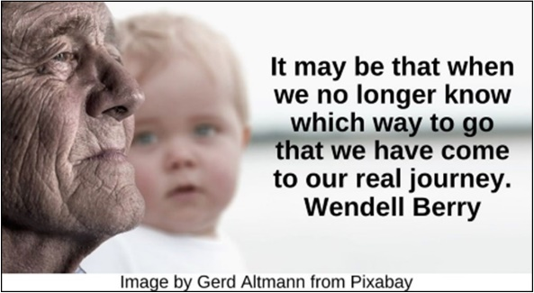

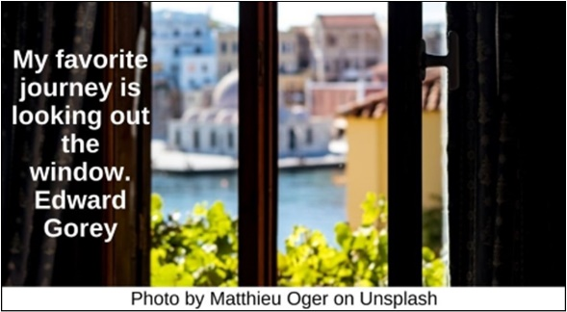

Text of Quotes
Baby HRJ
Life is an experimental journey undertaken involuntarily. Fernando Pessoa

Blade of Grass HRJ
I believe a leaf of grass is no less than the journey-work of the stars. Walt Whitman

Book HRJ
A book is as dangerous as any journey you might take. Mark Lawrence

Buddha HRJ
The road to enlightenment is long and difficult, and you should try not to forget snacks and magazines. Anne Lamott

Change HRJ
...there ain't no journey what don't change you some. David Mitchell

Child HRJ
Prepare the child for the path, not the path for the child. Betsy Brown Braun

Closed Eyes HRJ
The journey I'm taking is inside me. Haruki Murakami

Dance HRJ
Without music and dance, life is a journey through a desert. Pat Conroy

Diversity HRJ
We are on a journey to see that …our differences …is what makes us beautiful as a human race…. C. JoyBell C.

Footsteps HRJ
Your outer journey may contain a million steps; your inner journey only has one: the step you are taking right now. Eckhart Tolle

Imagination HRJ
Imagine! Imagine! the long and wondrous journeys still to be ours. Mary Oliver

Lessons HRJ
You never learn the most valuable lessons in life until you go through your own journey. Roy T. Bennett

Let Go HRJ
The beautiful journey of today can only begin when we learn to let go of yesterday. Steve Maraboli

Love Yourself HRJ
To love yourself is a never-ending journey. Oprah Winfrey

Next Step HRJ
The most important step a person can take is always the next one. Brandon Sanderson

No Fear HRJ
I knew that if I allowed fear to overtake me, my journey was doomed. Cheryl Strayed

Nowhere HRJ
What people forget is a journey to nowhere starts with a single step, too. Chuck Palahniuk

Resistance HRJ
I have learned so much from journeys I did not want to take. Suzy Kassem

Rocky HRJ
The journey of life …is a rocky path through the wilderness. M. Scott Peck

Secret HRJ
All journeys have secret destinations of which the traveler is unaware. Martin Buber

Shapes Us HRJ
We are not creatures of destinations. It is the journey that shapes us. Brandon Sanderson

Single Step HRJ
The journey of a thousand miles begins with a single step. Lao Tzu

Teddy Bear HRJ
Not all those who wander are lost. J.R.R. Tolkien

The End HRJ
“It is good to have an end to journey toward; but it is the journey that matters, in the end. Ursula K. Le Guin

Time to Choose HRJ
Sometimes it takes a wrong turn to get you to the right place. Mandy Hale

Toward Home HRJ
…our endless and impossible journey toward home is in fact our home. David Foster Wallace

Treat Those HRJ
It’s not so much the journey that’s important; as is the way that we treat those we encounter and those around us, along the way. Jeremy Aldana

Truth HRJ
Knowledge is a destination. Truth, the journey. Terry Goodkind

Unique HRJ
Your journey is your own and unique. Roy T. Bennett

Which Way HRJ
It may be that when we no longer know which way to go that we have come to our real journey. Wendell Berry

Window HRJ
My favorite journey is looking out the window. Edward Gorey

